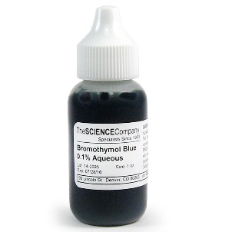**Acid Base Indicators**

* [**Indicators**](http://lightbook.pearsonplaces.com.au/#sec04222015160300336251) are large organic molecules whose colour changes in response to changes in the [**pH**](http://lightbook.pearsonplaces.com.au/#sec04222015160301732855) of the solution they are dissolved.
* They are either [**weak acids**](http://lightbook.pearsonplaces.com.au/#sec04222015160302142541) or [**weak bases**](http://lightbook.pearsonplaces.com.au/#sec04222015160302854307).
* In solution, the [**acid**](http://lightbook.pearsonplaces.com.au/#sec04222015160257645226) form of the indicator is in [**equilibrium**](http://lightbook.pearsonplaces.com.au/#sec04222015160259832115) with its [**conjugate base**](http://lightbook.pearsonplaces.com.au/#sec04222015160259202328) as shown in the following equation:

HIn(aq) + H2O(l) ⇌ In−(aq) + H3O+(aq

* The position of equilibrium changes depending on the pH.
* The colour of the acid form of an indicator, HIn, and the colour of its conjugate base, In− are different.
* The acid or base colour of an indicator is visible at low indicator concentrations.

The equilibrium principles studied in previous chapters also apply to indicators.

[**Le Châtelier's principle**](http://lightbook.pearsonplaces.com.au/#sec04222015160300150482) can be used to explain why indicators have different colours in acidic and basic solutions.

For example:

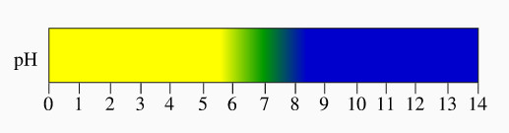Bromothymol Blue

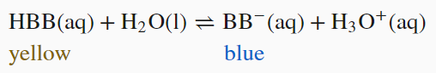

* Adding this indicator to an acid increases the hydrogen ion concentration and shifts the equilibrium to the left and it will turn yellow.
* Adding this indicator to a base results in the formation of water

[H+](aq) + [OH-](aq) 🡪 H2O(l)

This lowers the hydrogen ion concentration, shifting the equilibrium to the right turning the solution blue.

Watch this video

<https://www.youtube.com/watch?v=5bS7qt8cj7U>